**Static code analysis:**

* It is for run time exceptions, checking coding standards, duplicates. All the stuff will be done by static code analysis
* Internally for java, it runs on some tools called PMD/check styles/find bugs etc…
* with all these tools sonar comes up with one tool
* It runs the static analysis and reports the violations in sonar dashboard

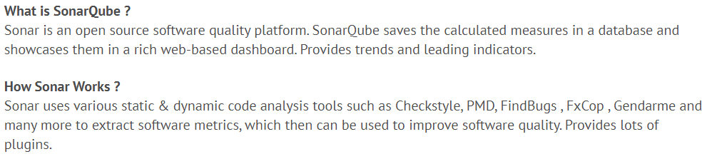

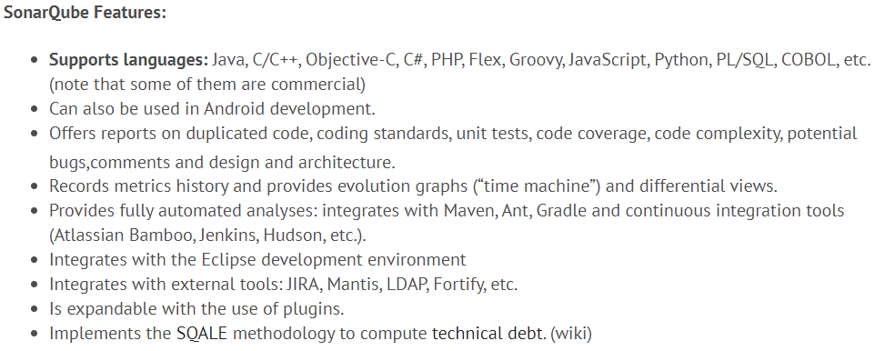



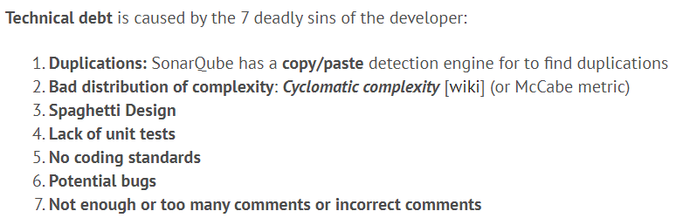

# Installation Prerequisites:

# 

# 

# 

# 

# 

# 

# 

# 

# 

# 